Bible Schools: A Vital Link in Reaching Nations

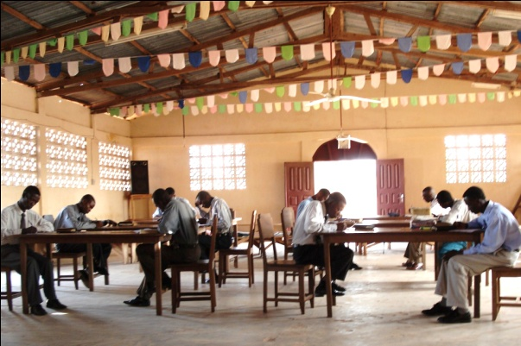
When Missionaries Randy and Carolyn Adams first arrived in West Africa, there were eight pastors and churches in Togo and twelve pastors ministering at fifteen churches in Benin. That was in 1996, over 15 years ago. If one were to visit the Eglise Pentecôtiste Unie Internationale these days, they would find the Lord doing great and mighty things: 30 licensed ministers with 40 churches in Togo, 34 pastors with 45 churches in Benin, and 7,500 members between the two nations! The tipping point of revival for this country? Bible School!
The Adams landed with a dream, a compelling desire to see African men and women equipped and empowered to reach their own people. They understood that only through a deliberate, methodical training program would the church be able to provide laborers for the vast, ripe harvest of souls in West Africa. In early 1997, they put feet to this dream by starting night classes and later that year, added day classes. These young men were soon joined by others from the neighboring country of Benin for an intense two year program in which they would, among many other things, discover the importance of the apostolic doctrine, consecration to Christian living and evangelism.
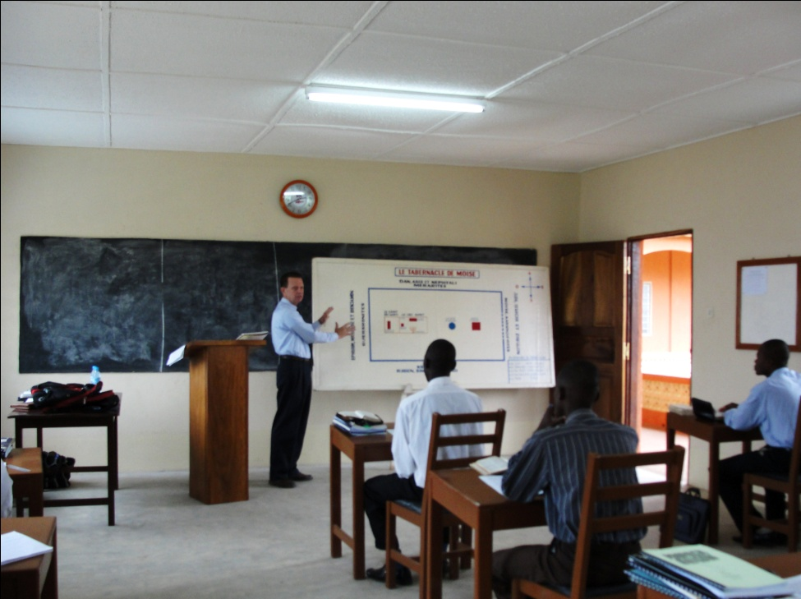
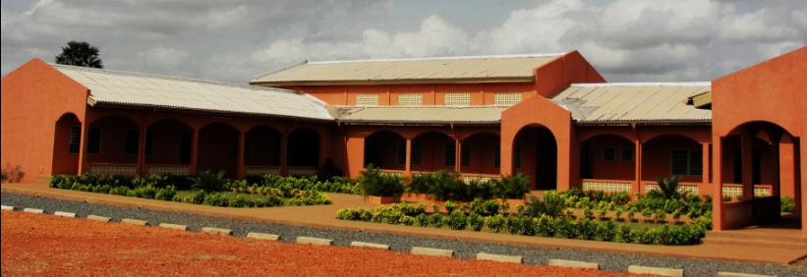
Aspirations for a building to house the training program were realized when donations given by North-American churches gave wings to this enduring vision. Construction began in February of 2008, a few miles out of the capital city of Lomé in an area called Adétikopé. The spacious compound was completed in July 2010 with a dedication held on September 18th, 2010. The facilities feature a building with three classrooms, a vaulted chapel with a seating capacity of 200, a conference room (for use by teachers and national board members), a printing room, in addition to a large dorm building that can house up to 32 students. Outdoor kitchen areas, electricity, running water from their own well, and a generator make the Bible School a comfortable place to learn, study and grow in the Word of God.
A shining example of Bible School students who have caught the fire of propagating the Truth is embodied in two students, Marc and Yao, from Benin. This dynamic, Holy Ghost anointed duo are consistently involved in evangelism while at school in Togo as well as in their native country Benin. During their last break, Marc and Yao helped start two vibrant churches, baptizing dozens and seeing many receive the Holy Ghost.
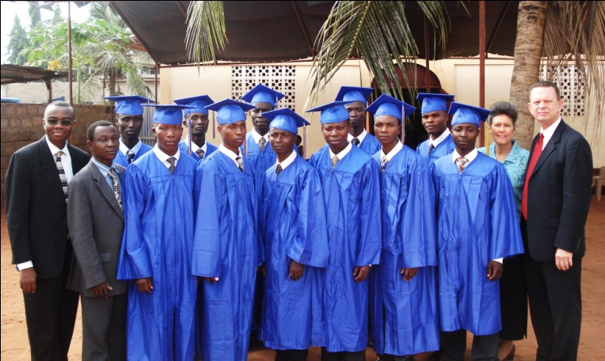
The ultimate goal of the United Pentecostal Church International is to create self-propagating, self-supporting, and self-governing churches worldwide; the most effective way to accomplish this is to train strong, doctrinally sound church leaders for the present and future. As a result of Bible School education, the country of Togo, in December 2011, elected their first national president, Reverend ADJINA K. Freeman, (who is, incidentally, also one of the Bible School Instructors). The EPUI in Togo was officially nationalized on February 13th, 2011 and handed over to Togolese officials, all of whom have attended Bible School in years past.
This Bible School, with a curricular emphasis on ministry, has had far reaching, international results as, over the years, it has trained ministers from the nations of Togo, Benin, Democratic Republic of Congo, Niger, and Senegal. Every graduating class has included not only Togolese students but also at least one Beninese. (There are currently four students from Benin attending classes due to limited funding.) Over 90% of the students who have graduated from this facility are working in churches around West Africa, touching the multitudes with the Gospel of Jesus Christ.

